The Project

## The Problem:

I have decided to create a 2D-Platformer (game) using the pygame library for python. I will have to create the environment, spites and physics for the game.

There are already existing 2D-Platformer games in existence such as the Mario or Sonic games and I am taking inspiration from the platformers that I have played to create a game that will have the features that I would want in a 2D-Platforming game.

There will be limitations to how much I can achieve such as the timeframe that I am limited to and the fact that is just me working on the project and that I am working alone and not in a development team.

Essential features…

Aspirational features…

Success criteria… (measurable)

## Planning:

I created a list of features that I wanted to implement and then ordered them from most important to least so that I had a basic plan to follow.

## Getting Started:

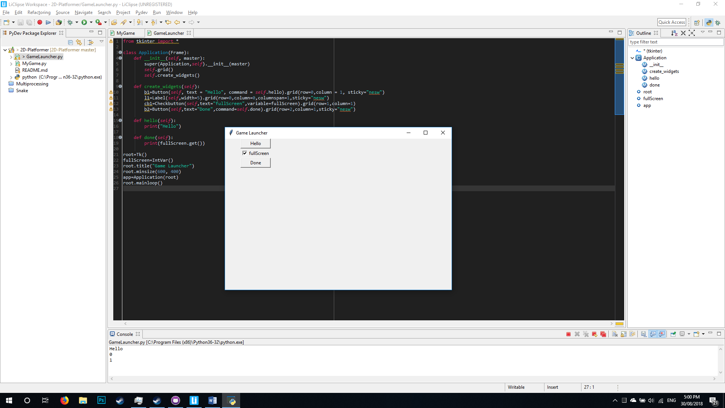I considered that the computer which the player is using might only have a low resolution monitor so I wanted the player to be able to choose the resolution before the game launched, this is why I decided to use the tkinter library to create a game launch menu.

I first got the basics working:

* I chose a resolution for the window which would still display on lower resolution monitors (600x400 pixels).
* I created a button to test that it would work and execute the specified command.
* I created a tick box and a button to output its current status for which I had to use .get()
* I also set the title of the window which may change later.